Digisuraksha Parihar foundation

PoC Report
1. Title
Proof of Concept – Stenographic File Integrity Checker

2. Objective
- File integrity check karna by hashing (SHA-256 / SHA3-256).
- Hashes ko directly store karne ke bajaye PNG image ke pixels me hide karna using LSB steganography.
- Stego image ko verify karke ensure karna ki file modify hui hai ya safe hai.

3. Scope
- Works with any files (PDF, TXT, DOCX, Images, etc.).
- Cover image must be PNG (lossless).
- Supports multiple files at once.
- User-friendly Web Interface using Flask + Tailwind CSS.

4. Tools & Technologies
- Language: Python 3
- Framework: Flask (for frontend-backend integration)
- Libraries: Pillow (image handling), hashlib (hash generation)
- Frontend: Tailwind CSS (for styling, responsive UI)

5. Methodology (Workflow)
Step 1 – Embedding
- User selects target files (whose hash will be hidden).
- User selects cover PNG image.
- System computes hash of each file (SHA-256/SHA3-256).
- JSON payload = {filename, hash, algo, timestamp} created.
- Payload embedded into PNG’s LSB (Least Significant Bits).
- Output: Stego Image (with hidden hashes).
Step 2 – Verification
- User uploads Stego Image.
- System extracts hidden payload (JSON).
- User optionally uploads current files.
- System compares embedded hash with current hash.
- Result displayed: ✅ OK (match), ❌ Mismatch (changed), ⚠ Not Checked.

6. Results / Screenshots
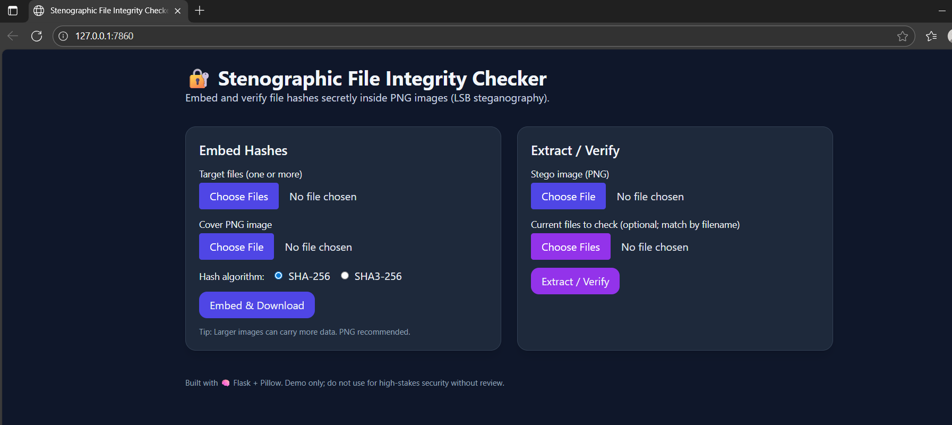
7. Security Considerations
- Data hidden with LSB Steganography (not visible to normal users).
- Current version does not encrypt payload (future scope).
- Integrity check is reliable (SHA-256/SHA3-256 are cryptographically strong).

8. Future Enhancements
- Add password-protected encryption for payload.
- Support audio (WAV) steganography as cover.
- Generate PDF/CSV verification reports.
- Deploy as a cloud service for remote usage.

9. Conclusion
This PoC demonstrates that file integrity verification can be achieved using steganography techniques. Instead of storing hashes in plain text, they are secretly embedded inside PNG images. This ensures security through obscurity while still enabling verification of data tampering.

